|  |
| --- |
| National Bank of Belgium |
| JD+ |
| Trading days effects |
|  |
| **Jean Palate** |
| **9/12/2017** |

## Definition of calendar effects

We consider in this document the regression variables that can be defined in JD+ to model trading days effects. We call them hereafter "calendar variables (TD)".

A natural way for modelling calendar effects consists in distributing the days of each period in different groups. The regression variable corresponding to a type of day (a group) is simply defined by the number of days it contains for each period. Usual classifications are:

* Trading days (7 groups): each day of the week defines a group (Mondays...Sundays)
* Working days (2 groups): week days and weekends

But we could also consider:

* 3 groups: week days (Mondays->Fridays), Saturdays, Sundays; that solution will be called TD3 hereafter
* ...

The definition of a group could involve partial days. For instance, we could consider that one half of Saturdays belong to week days and the second half to weekends

Specific holidays are often handled as Sundays: they go to the group that contains the Sundays (or more generally to the group corresponding to "non-working days"), but they also could be considered separately: for instance 8 groups: trading days (outside specific holidays) + specific holidays.

Example:

Week days + Saturdays + Sundays

|  |  |  |  |  |
| --- | --- | --- | --- | --- |
|  | **Total** | **Week days** | **Saturdays** | **Sundays** |
| Jan-2017 | 31 | 22 | 4 | 5 |
| Feb-2017 | 28 | 20 | 4 | 4 |
| Mar-2017 | 31 | 23 | 4 | 4 |
| Apr-2017 | 30 | 20 | 5 | 5 |
| May-2017 | 31 | 23 | 4 | 4 |
| Jun-2017 | 30 | 22 | 4 | 4 |
| Jul-2017 | 31 | 21 | 5 | 5 |
| Aug-2017 | 31 | 23 | 4 | 4 |
| Sep-2017 | 30 | 21 | 5 | 4 |

## Mean and seasonal effects of TD

The definition proposed above will lead to regression variables that have a mean effect and a seasonal effect. In the usual decomposition of a series, the mean effect (independent of the period) should be allocated to the trend-cycle component and the fixed seasonal effect (dependent of the period, 0 on average) should be affected to the corresponding component. So, the actual calendar effect should only contain effects that don't belong to the other components. Such a choice is just a sensible convention.

By mean effect and seasonal effect, we consider in JDemetra+ long term theoretical effects and not effects computed on the time span of the considered series (which should be continuously revised).

To correct the variables for their long term mean and seasonal effects, we just have to remove the long term means of each period. We apply below those corrections for the week days of TD3 (or TD2).

If we consider the variable "week days" in TD3 (or TD2), we have:

|  |  |  |
| --- | --- | --- |
| **Period (p)** | **Average number of week days** | **Average number of Saturdays/Sundays** |
| Jan | 31*5/7=22.1429 | 31/7=4.4286 |
| Feb | 28.25*5/7=20.1786 | 28.25/7=4.0357 |
| Mar | 31*5/7=22.1429 | 31/7=4.4286 |
| Apr | 30*5/7=21.4286 | 30/7=4.2857 |
| May | 31*5/7=22.1429 | 31/7=4.4286 |
| Jun | 30*5/7=21.4286 | 30/7=4.2857 |
| Jul | 31*5/7=22.1429 | 31/7=4.4286 |
| Aug | 31*5/7=22.1429 | 31/7=4.4286 |
| Sep | 30*5/7=21.4286 | 30/7=4.2857 |

For a given time span, the actual "calendar effects" is then easily derived.

|  |  |  |  |  |
| --- | --- | --- | --- | --- |
| **Time period (t)** | **# Week days** | **"Calendar effect"**  **of week days** | **# Sundays** | **"Calendar effect"**  **of Sundays** |
| Jan-2017 | 22 | -0.1429 | 5 | 0.5714 |
| Feb-2017 | 20 | -0.1786 | 4 | -0.0357 |
| Mar-2017 | 23 | 0.8571 | 4 | -0.4286 |
| Apr-2017 | 20 | -1.4286 | 5 | 0.7143 |
| May-2017 | 23 | 0.8571 | 4 | -0.4286 |
| Jun-2017 | 22 | 0.5714 | 4 | -0.2857 |
| Jul-2017 | 21 | -1.1429 | 5 | 0.5714 |
| Aug-2017 | 23 | 0.8571 | 4 | -0.4286 |
| Sep-2017 | 21 | -0.4286 | 4 | -0.2857 |

## Contrasts

The standard way to deal with trading days effects is based on contrasts. This is also the case in JD+.

Contrasts are defined as the (weighted) differences between the number of days in the groups of trading days and a “reference” group, which is by convention the “non-working” days (Sundays, week-ends...). For instance:

* TD7: #Mondays - #Sundays, ..., #Saturdays - #Sundays.
* TD3: #Week days – 5 * #Sundays, #Saturdays - #Sundays
* TD2: #Week days – 5/2 * (#Saturdays + #Sundays)

In the standard case, the weights of the contrasts, based on the number of days in each group, eliminate the mean and seasonal effects. However, this is no longer the case when we consider specific holidays.

## Handling of specific holidays

We consider in JD+ the following type of holidays:

* Fixed day, corresponding to a fixed date in the year (for instance July, 21 for Belgium, New Year, Christmas).
* Easter related days, corresponding to days that are defined in relation to Easter (Easter +- n days; example: Ascension...)
* Fixed week days, corresponding to a fixed day in a given week of a given month (Labour Day...)

From a conceptual point of view, specific holidays are handled exactly the same way as the other days. We just have to decide in which group they are put. Usually - and it is the convention used in JD+, they are handled has Sundays. Of course, except if the holiday falls on a Sunday, we have to correct both the group that should have contained the holiday and the group that contains the Sundays.

The trickiest aspect of specific holidays is the way they impact on the mean and the seasonal effects of TDs. We consider below the seasonal corrections that should be applied on the Mondays...Sundays following the kind of holidays.

The corrections are applied to the period(s) that can contain the holiday.

#### Fixed day

The probability that the holiday falls on a Sunday is 1/7 (and the same for the other days). The probability to have 1 Sunday more is 6/7. The effect on the means for the period that contains the date is (the correction on the calendar effect has the opposite sign):

|  |  |  |
| --- | --- | --- |
| **Sundays** | **Other days** | **Contrasts** |
| +6/7 | -1/7 | -1 |

We show below the impact of such day – 21 July, national holiday of Belgium – on TD7 (contrasts)

21 July falls on a Friday in 2017 and on a Sunday in 2019.

|  |  |  |  |  |  |  |
| --- | --- | --- | --- | --- | --- | --- |
|  | Monday | Tuesday | Wednesday | Thursday | Friday | Saturday |
|  |  |  |  |  |  |  |
| 01/07/2017  Default TD | 0 | -1 | -1 | -1 | **-1** | 0 |
| 01/07/2017  Belgium calendar (not corrected) | -1 | -2 | -2 | -2 | **-3** | -1 |
| Correction  (long term mean) | +1 | +1 | +1 | +1 | **+1** | +1 |
| 01/07/2017  Belgium calendar | 0 | -1 | -1 | -1 | **-2** | 0 |
|  |  |  |  |  |  |  |
| 01/07/2019  Default TD | +1 | +1 | +1 | 0 | 0 | 0 |
| 01/07/2017  Belgium calendar (not corrected) | +1 | +1 | +1 | 0 | 0 | 0 |
| Correction  (21 July on Sunday) | **+1** | **+1** | **+1** | **+1** | **+1** | **+1** |
| 01/07/2019  Belgium calendar | **+2** | **+2** | **+2** | **+1** | **+1** | **+1** |

#### Easter related days

Easter related days always fall the same week day (X). However, they can fall in different periods (months or quarters). Suppose that, taking into account the distribution of the dates for Easter, the probability that the holiday falls during the period m (m+1) is p (1-p). Then, the effects on the seasonal means are:

|  |  |  |  |  |  |
| --- | --- | --- | --- | --- | --- |
| Period | Sundays | Days X | Others days | Contrast X | Other contrasts |
| m | + p | - p | 0 | - 2*p | - p |
| m+1 | + (1-p) | - (1-p) | 0 | - 2*(1-p) | - (1-p) |

The distribution of the dates for Easter may be approximated in different ways.

A first solution consists in using some well-known algorithms for computing Easter on a very long period. JDemetra+ provides the Meeus/Jones/Butcher's and the Ron Mallen's algorithms (they are identical till 4100, but they slightly differ after that date).

Another approach consists in deriving a raw theoretical distribution based on the definition of Easter. It is the solution used for Easter related days. It is shortly explained below.

"Easter is the first Sunday after the full moon (the Paschal Full Moon) following the northern hemisphere's vernal equinox. Ecclesiastically, the equinox is reckoned to be on 21 March (even though the equinox occurs, astronomically speaking, on 20 March in most years), and the "Full Moon" is not necessarily the astronomically correct date. Easter is delayed by 1 week if the full moon is on Sunday. The date of Easter therefore varies between 22 March and 25 April" (Wikipedia). Taking into account that an average lunar month is 29.53059 days, we can derive raw formulae for the approximated distribution of Easter (they don't take into account the actual ecclesiastical moon calendar).

|  |  |
| --- | --- |
| 22/3 | 1/7 * 1/29.53059 |
| 23/3 | 1/7 * 2/29.53059 |
| 24/3 | 1/7 * 3/29.53059 |
| 25/3 | 1/7 * 4/29.53059 |
| 26/3 | 1/7 * 5/29.53059 |
| 27/3 | 1/7 * 6/29.53059 |
| 28/3 | 1/29.53059 |
| 29/3 | 1/29.53059 |
| ... | ... |
| 18/4 | 1/29.53059 |
| 19/4 | 1/7 * (6 + 1.53059)/29.53059 |
| 20/4 | 1/7 * (5 + 1.53059)/29.53059 |
| 21/4 | 1/7 * (4 + 1.53059)/29.53059 |
| 22/4 | 1/7 * (3 + 1.53059)/29.53059 |
| 23/4 | 1/7 * (2 + 1.53059)/29.53059 |
| 24/4 | 1/7 * (1 + 1.53059)/29.53059 |
| 25/4 | 1/7 * 1.53059/29.53059 |

For example,

The probability that Easter falls on 25/3 is computed as follows:

* Probability that 25/3 is a Sunday: 1/7
* Probability that the full moon is on 21/3... 24/3 is 5/29.53059

The probability that Easter falls on 23/4 is computed as follows:

* Probability that 23/4 is a Sunday: 1/7
* Probability that the full moon is on 16/4, 17/4: 2/29.53059
* Probability that the fool moon is on 18/4 1.53059/29.53059[1]

The different solutions are presented below.

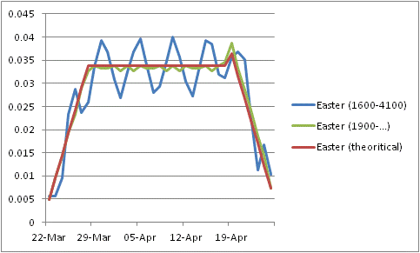

#### Fixed week days

Fixed week days always fall the same week day (X) and the same period. Their effect on the seasonal means is:

|  |  |  |
| --- | --- | --- |
| Sundays | Days X | Others days |
| + 1 | - 1 | 0 |

## Linear transformations of the TD

As far as RegArima models are considered, we can use any non-degenerated linear transformation of the TD; it will give the same results (likelihood, residuals, parameters, joint effect of TD, joint F-test on the coefficients of the TD...). The linearized series that will be further decomposed will be invariant to any linear transformation of the TDs.

However, it should be mentioned that choices of calendar corrections based on tests on the individual T-stats are dependent on the transformation, which is rather arbitrary. This is the case in old versions of Tramo-Seats.

Examples of linear transformation: *contrast variables*

The usual trading days variables are defined by the following transformation: the contrast variables (Mondays - Sundays ... Saturdays - Sundays) are used with the length of periods.

$$\left[\begin{matrix}1 & 0 & 0 & 0 & 0 & 0 & -1 \\ 0 & 1 & 0 & 0 & 0 & 0 & -1 \\ 0 & 0 & 1 & 0 & 0 & 0 & -1 \\ 0 & 0 & 0 & 1 & 0 & 0 & -1 \\ 0 & 0 & 0 & 0 & 1 & 0 & -1 \\ 0 & 0 & 0 & 0 & 0 & 1 & -1 \\ 1 & 1 & 1 & 1 & 1 & 1 & 1\end{matrix}\right]\left[\begin{matrix}M \\ T \\ W \\ T \\ F \\ Sat \\ S\end{matrix}\right]=\left[\begin{matrix}M-S \\ T-S \\ W-S \\ T-S \\ F-S \\ Sat-S \\ Length of period\end{matrix}\right]$$

For the usual working days variables, we use:

$$\left[\begin{matrix}1 & -5/2 \\ 1 & 1\end{matrix}\right]\left[\begin{matrix}Week \\ Weekend\end{matrix}\right]=\left[\begin{matrix}Contrast week \\ Length of period\end{matrix}\right]$$

For TD3, we could use (other solutions are possible):

$$\left[\begin{matrix}1 & 0 & -6 \\ 0 & 1 & -1 \\ 1 & 1 & 1\end{matrix}\right]\left[\begin{matrix}Week \\ Saturday \\ Sunday\end{matrix}\right]=\left[\begin{matrix}Contrast week \\ Contrast saturday \\ Length of period\end{matrix}\right]$$

Those transformations have several advantages. They suppress from the contrast variables the mean and the seasonal effects, which are concentrated in the last variable. They also lead to less correlated variables, which are better estimated.

Auto-correlation matrix of the contrast variables (Monday-Sunday, … Monday-Saturday, length of month). From 1980 to 2008

|  |  |  |  |  |  |  |
| --- | --- | --- | --- | --- | --- | --- |
| 1 | 0.703167 | 0.50303 | 0.310087 | 0.134313 | 0.011111 | 0 |
| 0.703167 | 1 | 0.788875 | 0.573282 | 0.342697 | 0.134313 | 0 |
| 0.50303 | 0.788875 | 1 | 0.807692 | 0.573282 | 0.310087 | 0 |
| 0.310087 | 0.573282 | 0.807692 | 1 | 0.788875 | 0.50303 | 0 |
| 0.134313 | 0.342697 | 0.573282 | 0.788875 | 1 | 0.703167 | 0 |
| 0.011111 | 0.134313 | 0.310087 | 0.50303 | 0.703167 | 1 | 0 |
| 0 | 0 | 0 | 0 | 0 | 0 | 1 |

## Impact of the mean and seasonal effects

When the Arima model contains a seasonal differencing - something that should always happen with TD - the mean and the seasonal effects contained in the TDs are automatically eliminated, so that they don't modify the estimation. The model is indeed estimated on the series/regression variables after differencing.

However, they lead to a different linearized series ($y_{lin})$. We will consider below the impact of other corrections (mean and/or fixed seasonal) on the decomposition.

Consider first a model with "correct" calendar effects (C), i.e. effects without mean and fixed seasonal effects. To simplify the problem, the model has no other regression effects.

We can write:

$$y_{lin}= y-C$$

$$T= F_{T}\left(y_{lin}\right)$$

$$S= F_{S}\left(y_{lin}\right)+C$$

$$I= F_{I}\left(y_{lin}\right)$$

where $F_{X}$ is the linear filter for the component X.

Consider next other calendar effects ($\tilde{C}$) that contain some mean (cm, integrated to the final trend) and fixed seasonal effects (cs, integrated to the final seasonal).

We have now:

$$\tilde{C}=C+cm+cs$$

$${\tilde{y}}_{lin}= y-\tilde{C}= y_{lin}-cm-cs$$

$$\tilde{T}= F_{T}\left({\tilde{y}}_{lin}\right)+cm$$

$$\tilde{S}= F_{S}\left({\tilde{y}}_{lin}\right)+C+cs$$

$$\tilde{I}= F_{I}\left({\tilde{y}}_{lin}\right)$$

Taking into account that $F_{X}$ is a linear transformation and that[2]

We have:

$$\tilde{T}= F_{T}\left({\tilde{y}}_{lin}\right)+cm=F_{T}\left(y_{lin}\right)-cm+cm=T$$

$$\tilde{S}= F_{S}\left({\tilde{y}}_{lin}\right)+C+cs=F_{S}\left(y_{lin}\right)-cs+C+cs=S$$

$$\tilde{I}= I$$

If we don't take into account the effects and apply the same approach as in the "correct" calendar effects, we will get:

$$\breve{T}= F_{T}\left({\tilde{y}}_{lin}\right)=T-cm$$

$$\breve{S}= F_{S}\left({\tilde{y}}_{lin}\right)+\tilde{C}=S+cm$$

$$\breve{I}= F_{I}\left({\tilde{y}}_{lin}\right)=I$$

The trend, the seasonal and the seasonally adjusted series will only differ by a (usually small) constant.

So, the decomposition doesn't depend on the mean and fixed seasonal effects used for the TDs, provided that those effects are integrated in the corresponding final components. If we don't take into account those corrections, the main series of the decomposition will only differ by a constant.

## Trading days and periodograms

Trading days variables correspond to some very specific frequencies. We present below the periodogram of the working days variable for different annual frequencies, on a very long period (280 years)

Monthly variables

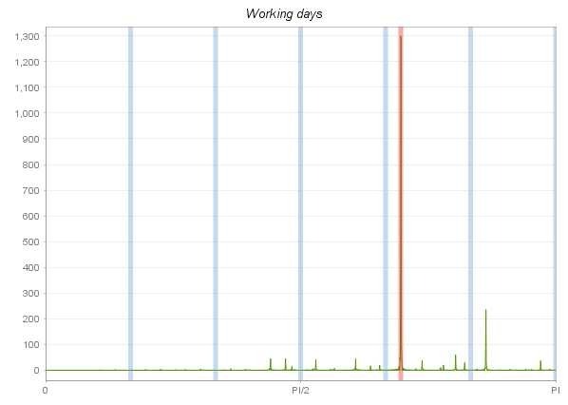

Quarterly variables

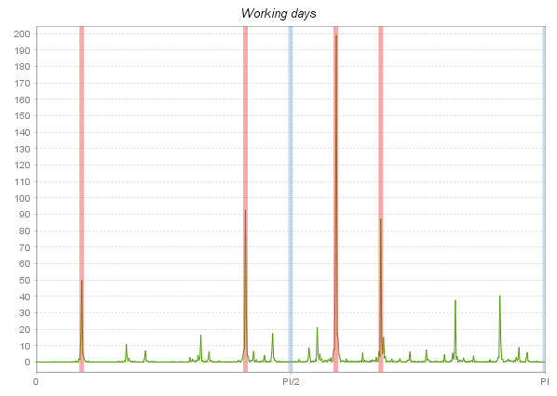

Quadri-monhtly variables

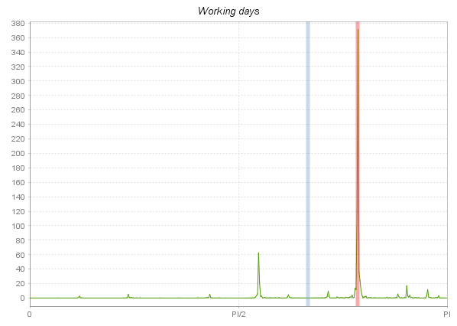

The frequency of the main periodogram peaks can be easily computed for each annual frequency as follows:

Using figures on regular calendar periods (months, quarters…), the only relevant information we have on week effects comes from incomplete weeks (if every month would have 28 days, we would not be able to detect trading days effects).

Considering an annual frequency (number of observations during one year) F and taking into account that one year contains in average 365.25 days, the average incomplete week by period is

365.25/F modulo 7. The number of periods to get a “complete week” is then 7 divided by that ratio. The corresponding frequency in the periodogram is 2*pi/ the number of periods

|  |  |  |  |
| --- | --- | --- | --- |
| Annual frequency | Average incomplete week (in days) | Number of periods to get a complete week | Frequency |
| 12 | 2.4375 | 2.8718 | 2.1879 |
| 4 | 0.3125 | 22.4 | 0.2805 |
| 3 | 2.75 | 2.5455 | 2.4684 |

To be noted that the theoretical peak of quarterly series isn’t the most important observed peak.

1. 18/4 is the last acceptable date for the full Moon.
2. In the case of Seats, the properties can be trivially derived from the matrix formulation of signal extraction.

   They are also valid for X11 (additive)